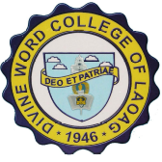
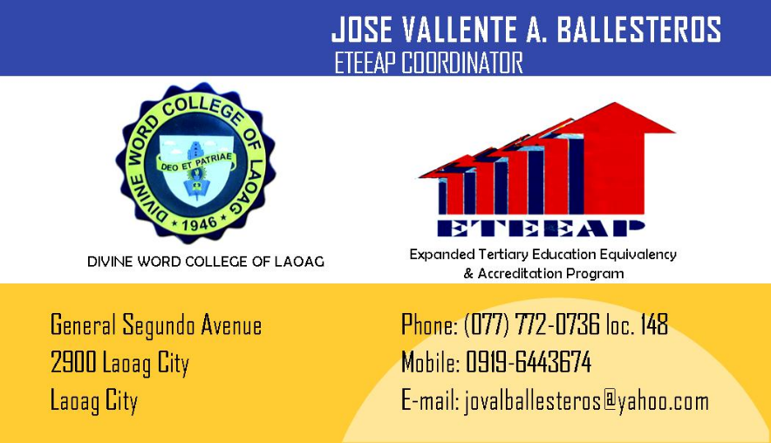

Coordinator makes initial interview and assessment of the applicant
Applicant meets minimum qualifications?

Applicant is advised
accordingly

START
Applicant is advised to
accomplish application form & to submit such together with pertinent documents to the DWCL
Coordinator organizes the Panel of Assessors and Interviewers for documents and skills evaluation
Applicant proceeds to
undertake assessment in DWCL
Panel of Assessors
evaluates documents
submitted.
Panel of Interviewers
conducts worksite/skills evaluation.
Panel of Experts assesses & determines applicant’s
extent and level of
competencies.
Applicant takes residency units required to finish
degree.
Applicant satisfies competencies for
degree?
Applicant avails of competency
enhancement
services/programs.
Formal Education:
applicant enrolls
supplementary units to satisfy
competencies for
degree.
Applicant completes
requirement
DWCL awards degree to successful candidate.
DIVINE WORD COLLEGE OF LAOAG
EXPANDED TERTIARY EDUCATION EQUIVALEnCY AND ACCREDITATION PROGRAM
NO
YES
NO
END
YES
ASSESSMENT PROCEDURE FLOWCHART

